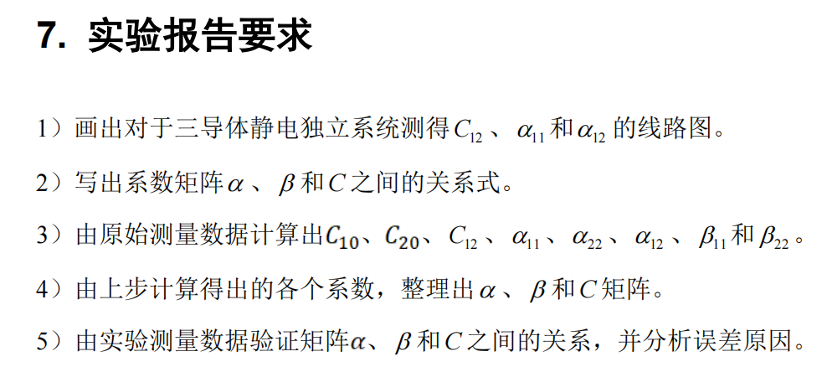

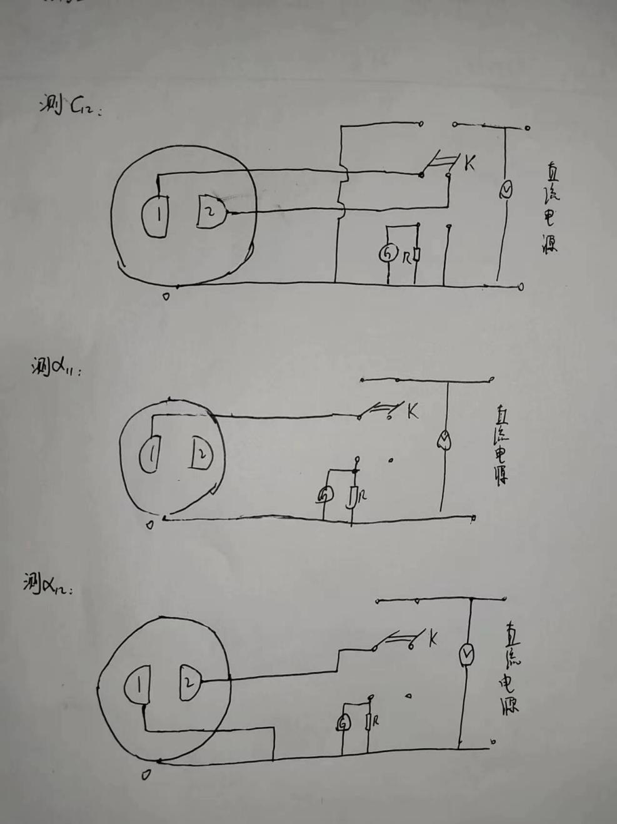



NO. 5

|  |  |  |  |
| --- | --- | --- | --- |
| 系数 | 次数 | 电压(V) | 电荷(nC) |
| **β11** | 1 | 30.00 | 24.8 |
| 2 | 30.00 | 24.5 |
| 3 | 30.00 | 24.7 |

|  |  |  |  |
| --- | --- | --- | --- |
| 系数 | 次数 | 电压(V) | 电荷(nC) |
| **β22** | 1 | 30.00 | 16.4 |
| 2 | 30.00 | 16.6 |
| 3 | 30.00 | 16.3 |

|  |  |  |  |
| --- | --- | --- | --- |
| 系数 | 次数 | 电压(V) | 电荷(nC) |
| **C10** | 1 | 30.00 | 11.2 |
| 2 | 30.00 | 11.1 |
| 3 | 30.00 | 11.2 |

|  |  |  |  |
| --- | --- | --- | --- |
| 系数 | 次数 | 电压(V) | 电荷(nC) |
| **C20** | 1 | 30.00 | 3.0 |
| 2 | 30.00 | 3.0 |
| 3 | 30.00 | 3.1 |

|  |  |  |  |
| --- | --- | --- | --- |
| 系数 | 次数 | 电压(V) | 电荷(nC) |
| **C12** | 1 | 30.00 | -13.9 |
| 2 | 30.00 | -13.8 |
| 3 | 30.00 | -13.7 |

|  |  |  |  |
| --- | --- | --- | --- |
| 系数 | 次数 | 电压(V) | 电荷(nC) |
| **α11** | 1 | 30.00 | 14.3 |
| 2 | 30.00 | 14.4 |
| 3 | 30.00 | 14.2 |

|  |  |  |  |
| --- | --- | --- | --- |
| 系数 | 次数 | 电压(V) | 电荷(nC) |
| **α22** | 1 | 30.00 | 9.4 |
| 2 | 30.00 | 9.6 |
| 3 | 30.00 | 9.7 |

|  |  |  |  |  |
| --- | --- | --- | --- | --- |
| 系数 | 次数 | 电压(V) | 电荷1(nC) | 电荷2(nC) |
| **α12** | 1 | 30 | 11.6 | 3.6 |
| 2 | 30 | 11.6 | 3.5 |
| 3 | 30 | 11.6 | 3.5 |